Integration of Expression Data and Genotype Data:
Application of Chronic Fatigue Syndrome Data
Eunjee Lee${}^{1}$, Seoae Cho${}^{1}$, Teasung Park${}^{2}$
1. Interdisciplinary Program in Bioinformatics, Seoul National University, Seoul, Korea
2. Department of Statistics, Seoul National University, Seoul, Korea

Motivation
DNA microarray data and SNP genotypes data can be obtained from the same patient simultaneously. at the same time. There have been several approaches available to the analysis of DNA microarray data and SNP genotypes data separately. In the analysis of DNA microarray data, for example, the identification of differential expression between two groups is of great interest, and several statistical tests have been proposed. In analyzing SNP data, the logistic regression approach is commonly used to detect associations between disease and SNP genotypes.
However, for the analysis of complex diseases, it would be quite informative to use both types of data: DNA Microarray and SNP data, because one type of data may represent only partial information for a disease. Two types of data may account for other aspects of disease which cannot be explained by only one type of data, especially for complex disease with many diverse causes. Chronic Fatigue Syndrome (CFS) is known to be a complex disease with several genes related with[1]. Thus, it is appropriate to consider more than one data type together for investigating the characteristics of CFS. Furthermore, it is important to consider gene-gene interaction in studying such a complex disease.
In this paper, we focus on extracting information regarding CFS by integrating DNA microarray data and SNP data. Note that these two data have quite different information. It is important to recognize the fundamental differences between two datasets. DNA Microarray data provides the information regarding the mRNA level of genes expressed, while the SNP data does regarding the difference in genetic level over individuals. We expect that the SNP data affects on the mRNA data, directly or indirectly. So, it is essential to consider the relation between these two data for integrating them. In this paper, we first propose using two-way analysis of variance (ANOVA) model approach to combine SNP data and DNA microarray data. The results of the integrated analysis will be compared with those from the separate analyses.

Method and Result
- Association test between SNPs and CFS
  - Association between SNPs and CFS
The association between SNPs and disease are detected using the logistic regression. We focus on comparing pairwise comparison between groups. In comparing SNP frequencies of Ever CFS groups and Nonfatigued group, the signifnicant SNPs are rs6188(p=0.001968), rs860458(0.004318) , rs852977(p=0.004318), rs6188(p=0.01054), and rs6196(p=0.01054) in gene NR3C1.
In comparing SNP frequencies of Ever CFS-MDDm groups and Nonfatigued group, the list of significant genes is different. The significnant SNPs are rs933271(p=0.00289) and rs5993882(p=0.002601) in gene COMT.
  - Gene-gene interaction using SNPs data
We analyze the gene-gene interaction using the logistic regression model. In comparing Ever CFS and Nonfatigued groups assuming the recessive model, the interaction term between rs740603 in COMT and rs1866388(p=0.02902) in NR3C1 and rs852977(p=0.02189) in NR3C1 are significant. In codominant model, the second order of interaction term between rs2070762 and rs1799836, rs2070762 and rs10784941, rs4760816 and rs1872824, rs4760816 and rs6196, rs4760816 and rs258750, rs4760816 and rs860458, rs4760816 and rs2918419, rs4760816 and rs140701, rs1872824 and rs933271 are significant. The CFS frequencies according to genotypes of two genes are shown in Figure 1. In the interaction test, we can detect several pairs of interactions of genes which are not detected by association using the one SNP. As shown in Figure1, the frequency of CFS is different conditioning on genotype of other SNPs,
- Analysis between gene expression level and CFS
  - t-Test and BayesReg, regularized t-Test
We tested the difference of expression level between two groups: 1) Ever CFS and Nonfatigued groups 2) Ever CFS-MDDm and Nonfatigued groups 3) Ever CFS and Ever CFS-MDDm groups, by using the t-test, SAM test [2] and Bayesian regression approach[3]. However, none of these tests yielded significant results.
- Integreated analysis of gene expression data and SNP data
We tested the dfferentially expressed gene according to disease groups, conditional on SNP genotype.
  - Two-way ANOVA
We examine effects of SNPs and disease groups on expression level using two-way ANOVA model. Let$Y_{\text{ijk}}$ represent the gene expression level of the $k^{\text{th}}$observation within the ${\text{ij}}^{\text{th}}$ treatment group. Then, the two-way ANOVA model is given by $E(Y_{\text{ijk}})=μ+α_{i}+β_{j}+{\text{αβ}}_{\text{ij}}$ where $α_{i}$ represents the effect of factor A for the SNPs genotypes assuming a codominant model main effects (i=0,1 in recessive model SNP genotypes), $β_{j}$ represents the disease group, and ${\text{αβ}}_{\text{ij}}$ represents the AB interaction effects.
In ever CFS group and Nonfatigued group, rs258750 in NR3C1 (assuming the recessive model) is shown to have influences on the expression level of 148 genes. On the other hand, no significant effect of group or interaction effects were detected. However, in ever CFS-MDDm groups and Nonfatigued group, the significant interaction effects between rs6188 in NR3C1 gene and disease group were significant on the gene expression levels of 226 genes.
In ever CFS group and ever CFS-MDDm group, we detected the significant effects of the group of CFS or CFS-MDDm on the gene expression level conditioning on SNP genotypes. First, SNPs, rs860458 and rs2918419 in NR3C1 have significant effects on 101 genes. The interaction effect between group and genotype is significant on 199 genes. Another SNP, rs1396862 in CRHR1 also has a significant effect on the gene expression levels of 146 genes and its interaction effect is significant on the gene expression level of 134 genes.
Figure2 represents the mean difference of gene expression between Ever CFS and Ever CFS-MDDm for rs860458 in NR3C1. They are a partial result of the two-way ANOVA analysis showing similar pattern of gene expression levels for genotype and groups. These genes turn out to have same Gene ontology, related with transcription. Other genes having the same gene ontology term from other tests also have common patterns of gene expression level according to the genotype and disease groups(results are not shown).
b. Gene ontology analysis using GOstat
We identified gene ontology(GO) terms enriched for the genes whose expression were shown to change significantly from the two-way ANOVA analysis. Using GOstat[6], we identified statistically overrepresented GO terms within a group of genes. All gene ontology results came from GOstat by using the significance level 0.05 after the multiple correction of Benjamin and Hochberg method.
All genes were grouped by gene Ontology term and indicated overrepresented GO terms. In two-way ANOVA analysis, with factors of rs860458 in NR3C1 and disease groups, the 164 genes showed that only interaction effect are overrepresented in transcription (a part of genes are shown in Figure2) , regulation of biological process, protein binding function and components of intracellular membrane bound organelle and nucleus (only genes related with transcription are shown in table1). All other gene sets of other results are also grouped by gene ontology (the results are not shown)

Discussion
For characterizing CFS, we performed t-test, ANOVA test, SAM test[2], and BayesReg test[3] for the DNA microarray data, but we could not obtain any significant results. In contrast, the SNP data analysis yielded several significant results from the logistic regression analysis. However, it is difficult to characterize the CFS thoroughly using the results from SNP data. Both SNP data as well as DNA microarray data would have only partial information about CFS. Thus, it becomes more desirable to integrate these two types of data together. We expected that the SNP data and microarray data would compensate each other by making up for incomplete information not accounted by other data set.
In comparing Ever CFS and Nonfatigued groups, the SNP data provide more information on Ever CFS more than gene expression data. We can detect the direct effects of all SNPs of NR3C1 gene on disease using the logistic regression model. NR3C1, glucocorticoid receptor which regulates glucocorticoid levels in blood, showed a significant association with fatigue, because the level of glucocorticoid in Hypothalamic-pituitary-adrenal(HPA) axis has a significant effect on fatigue[7]. In addition, the logistic regression model with the gene-gene interactions detected several significant interactions that are supported by several evidences, sharing common biological pathway (HPA axis) or relationship with neurotransmitter such as dopamine and serotonin in the mammalian brain [4,5,7,8]. In analysis of DNA microarray data, on the other hand, we could detect direct effects of NR3C1 genotype on gene expression in mononuclear cell, which was supported by the evidence of neuroendocrine regulation of immunity[4]. However it was not of our main interest because this effect was not related with disease.
In comparing Ever CFS-MDDm and Nonfatigued groups, the integrated analysis using two data types yielded a significant interaction effect between rs1688 in NR3C1 and group on 226 gene expression level, while rs1688 had no direct effect on gene expression level. From these results, we can conclude that rs1688 is a confounding factor. In SNP data analysis, SNPs in gene COMT, catechol-o-methyltransferase gene which regulates the concentration of neurotransmitters, dopamine, epinephrine, and norepinephtrin[5], is highly associated with disease group . However, SNPs in COMT gene as well as disease groups are not related with the gene expression level of any genes in DNA microarray. So, we conclude that dysfunction in COMT gene effect on disease not through immune system disorder, especially mononuclear cell. In comparing Ever CFS-MDDm and Ever CFS groups, the results are slightly different from the two previous results. The integrated analysis of DNA microarray data and SNPs data using two-way ANOVA showed that, rs291819 and rs860458 in NR3C1 and rs1396862 in CRHR1 differentiated the expression levels of several genes. As shown in Figure1, these genes, especially in common ontology named transcription, show the common pattern of gene expression.
In conclusion, Ever-CFS and Ever CFS-MDDm have different pathways to provoke the disease even though they have common symptoms, CFS. The integreated analysis provided more informative results than the separate analyses of DNA microarray data and SNPs data in characterizing CFS that has several possible causes.

Reference
- Rolf H.Adler,Chronic fatigue syndrome(cfs),SWISS MED WKLY,2004:134:268-176
- V.Tusher, R.Tibshirani, G.Chu, Significance analysis of microarrays applied to the ionizing radiation response, PNAS, 2001, 98:5177-5121
- Baldi,P.,Long,AD, Bayesian framework for the analysis of microarray expression data: regularized t-test and statistical inferences of gene changes, Bioinformatics 17,2001,509-519
- Jeanette I. Webster, Leonardo Tonelli, Neuroendocrine regulation of Immunity, Annu.Rev.Immunol.2002.20:125-63
- Principles of Neural Scienece, Kandel, Schwartz and Jessell, Fourth edition
- http://gostat.wehi.edu.au/
- A.Chaudhuri, P.O.Behan, Fatigue in neurological disorders, THE LANCET,363,2004,978-988
- X.Zhang, et al., Trptophan Hydroxylase-2 controls Brain Serotonin Synthesis., Science,305,2004.

Table 1 Groups of genes( only related with transcription) which is differentially expressed, interaction effect between genotype of rs860458 in NR3C1 gene and disease groups, Ever CFS and Ever CFS-MDDm
Gene group | Gene symbol
Transcription  (Regulation of nucleobase, nucleoside, nucleotide metabolism and transcription) | TBL1XR1 TLE4 ERN1 RARG POLR2L CREBL2 RUNX1T1 RFX2 CDC2L2 MLL PIAS2 DYRK1B SNAPC4 TRIP13 NANOG GCN5L2 JUNB HKR3 MLL3 SREBF1 HDAC7A TERF2 TCF1 UHRF1 HDAC7A

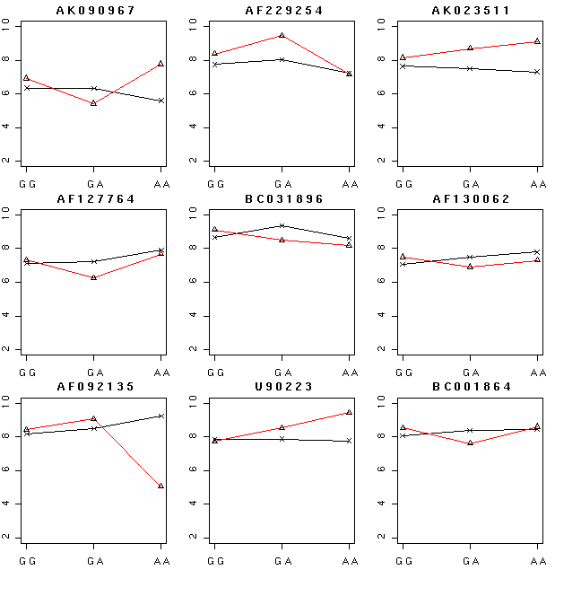
Figure 2 Mean of gene expression level according to rs860458 in NR3C1 genotypes and disease groups. Red line represents Ever CFS-MDDm groups and black line represents Ever CFS groups. All genes have the common gene ontology and transcription.
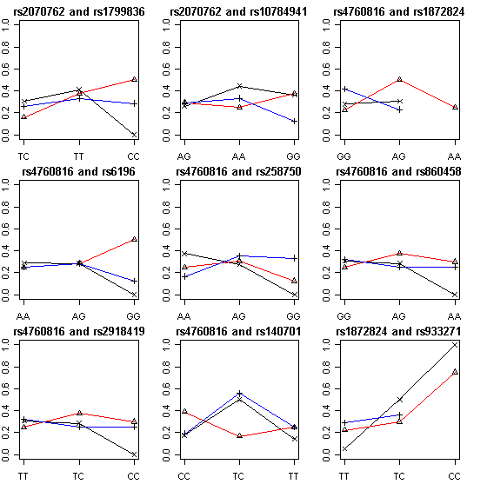
Figure 1
The CFS frequency over genotypes of two genes. Black line represents genotype which has the lowest frequency, red line genotypes of median frequency and blue line genotypes of highest frequency in the codominant model

