Does CFS have a biological basis? – A constructionist approach
Paul J. Kennedy¹* , Simeon J. Simoff¹, Daniel R. Catchpoole², Franco Ubaudi¹, Ahmad Al-Oqaily¹, Seyhan Yildiz¹, Ying Du¹ and David B. Skillicorn ³.
1. Faculty of IT, University of Technology, Sydney, PO Box 123, Broadway NSW 2007, AUSTRALIA
2. The Oncology Research Unit, The Children’s Hospital at Westmead, Locked Bag 4001, Westmead NSW 2145, AUSTRALIA
3. School of Computing, Queen’s University, Kingston, CANADA

Proposed analytical objective
One objective of the proposed investigation into Chronic Fatigue Syndrome [3] is to derive a definition of the syndrome which goes beyond a clinical assessment of symptoms to an empirical diagnosis founded on an established biological lesion. Specifically, Objective 1, aim 3 states ‘To identify biological markers that may be diagnostic of CFS.’ and Objective 2, aim 3 states ‘To identify biological markers that may be diagnostic of fatiguing illnesses other than CFS’. The key biological assumption being made by the investigators is that there is a biological basis to the aetiology of CFS and that this should be apparent at the genetic level within peripheral blood. According to the investigators, there is no physical, anatomical, or laboratory markers for CFS and its aetiology and pathophysiology is currently unknown. As indicated by the investigators, such medically unexplained disorders are ‘typically multifactorial’ [4]. As such, data which cover the full biological genotype to phenotype spectrum, has been supplied for interrogation to uncover the biological foundation to CSF (see Fig. 1). In particular, the investigators have developed a stratification of CFS which characterises its clinical significance [6] and they hypothesise that gene expression profiling will allow them to establish prognostic indicators of the syndrome.
Fig. 1. Relationship of data source to biological genotype to phenotype spectrum.
In our analysis, we have queried this primary assumption and asked whether there is a biological basis to CFS or does it have a purely psychosocial aetiology. In particular we have focussed on whether we can identify a pathological lesion for CFS in peripheral blood. Put more simply, in what way, and to what extent, are the SNP, gene expression, proteomic and blood chemistry profiles different between non-fatigued (NF) subjects and those with CFS or a fatigue syndrome? As a first step, we select to compare NF with the combination of CFS and ISF because the latter groups exhibit fatigue symptoms.

A brief summary of the analytical effort
To address this research question we take a complex systems approach towards the syndrome. Hence, we combine constructionist and reductionist approaches in our analytical effort, as shown in Fig. 2. Our constructionist approach takes into account an integrated dataset of clinical and gene expression data and investigates the global patterns and links such as clusters of patients in the space of the integrated dataset. Our reductionist approach uses subsets of attributes to discover local patterns. Such reductionist approaches are common in microarray data analysis and form the basis of research attempting to discover disease specific ‘biomarkers’. However, applying reductionist approaches to highly multidimensional datasets are insufficient for two reasons. Firstly, such datasets are highly liable to choosing biological markers (genes) that differentiate between classes of patient in one dataset but do not generalise well to unseen cases (ie. type I errors). This is a result of insufficient patient samples compared to the data items collected per sample. The investigators [3] chose sufficient numbers of patients for the clinical data, but this number of patients is insufficient for highly dimensional gene expression or proteomics data. Secondly, given the already stated predicted ‘multifactorial’ nature of the aetiology of CFS, it is likely then to be multigenic in nature with small changes across a system(s) of genes, rather than a single gene or simple genetic defect. In our analytical approach we take a data driven strategy of exploration of the research question before generating a hypothesis. In this way, we aim at getting better understanding of the phenomena and avoiding the introduction of unnecessary bias into the study.
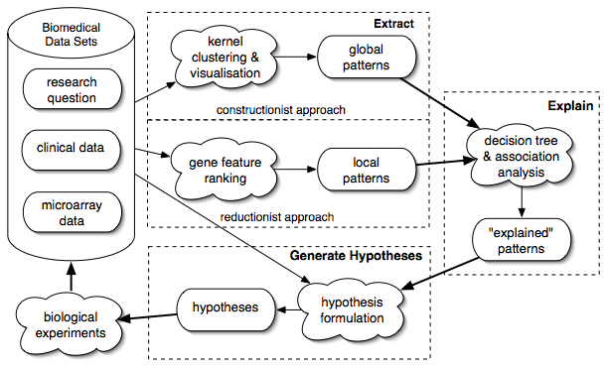
Fig. 2. Analytical approach

Data integration and preprocessing
The CAMDA 2006 competition datasets were used for the analysis in this study. The “Illness Classification SF36 MFI and Symptoms” dataset was preprocessed in the following way. The attributes “DOB”, “intake classific”, “cluster”, “onset”, “yrs ill”, “race” and “ethnic” were omitted as these attributes were either very skewed, not useful for data mining or computed by the researchers. We combined subtypes of patient classes in the “Empiric” field into “CFS”, “ISF” or “NF”. For example, “CFSMed” and “CFS/MDDm” were labelled under the “CFS” class. In the “Complete Blood Evaluation” dataset we added a copy of the “Empiric” attribute and removed the collection date and time attributes. Patients with missing class value were omitted from the datasets.
The gene expression datasets were combined into one dataset consisting of rows with the attributes “Patient ID”, “Array Name”, “Spot labels”, “ARM Dens - Levels”, “MAD - Levels” and “SD - Levels”. The “Patient ID” and “Array Name” attributes were populated by splitting the name of the gene expression file into the corresponding two parts. The other four attributes were populated from the individual gene expression files. Other attribute values in the individual gene expression files were not used. The “ARM Dens - Levels”, “MAD - Levels” and “SD - Levels” attributes were normalised by multiplying values with average value of every gene over all arrays divided by the average value of every gene over the individual array. The patient class derived from the “Empiric” attribute was linked with the gene expression values.
From the individual datasets we construct integrated datasets with pairs and the triplet of the preprocessed “Complete Blood Evaluation”, “Illness Classification SF36 MFI and Symptoms” and gene expression datasets. There is a one-to-one mapping between patients in the preprocessed “Complete Blood Evaluation” and “Illness Classification SF36 MFI and Symptoms” datasets. The integrated blood and illness dataset comprised all these patients. The gene expression dataset consisted of a subset of the patients with clinical data, plus a few patients with no clinical information. Also, a few patients were represented more than once in the gene expression dataset with multiple arrays. The datasets integrating gene expression data consisted of the subset of patients with both clinical data and gene expression data. The patients with multiple arrays were represented with repeated clinical data.

Approach
In this study we apply three analysis techniques. (I) A kernel based clustering and visualisation technique is applied to the individual and integrated datasets. (II) A new feature selection technique called Gene Feature Ranking (GFR) is applied to the gene expression dataset to identify genes that best discriminate between two classes: “CFS” (including ISF patients) and NF. (III) Decision tree and association analysis is applied to the “Complete Blood Evaluation” and “Illness Classification SF36 MFI and Symptoms” datasets to better understand the global and local patterns.

Kernel-based clustering and visualisation
This method [7] finds a low-dimensional projection of the integrated dataset such that the distance between points in the projection is similar to the distance in the kernel induced feature space. We apply linear and Gaussian kernels to the data, but report only the linear as it was sufficient in depicting relationships. For this method the additional preprocessing includes: (i) all fields of both the “Complete Blood Evaluation” and the “Illness Classification SF36 MFI and Symptoms” datasets were recoded to numeric values; (ii) patient class information was omitted from all the datasets and the data was centred and normalised.
Efficient calculation of the kernel matrix for the gene expression data requires special treatment. Each row of this dataset represents an individual spot label measurement for a particular array (for each patient). The existing approach of calculating the linear kernel matrix is to concatenate the rows of the gene expression dataset into a matrix consisting of one row for each array with a set of attribute values for each spot label (“ARM Dens - Levels”, “MAD - Levels” and “SD - Levels”) then to calculate the linear kernel by multiplying the matrix with its transpose. This approach is not practical in this situation because of the large number of spot labels on each the array. We propose a more effective approach, motivated by computational linguistics, for direct computation of the linear kernel matrix from the gene expression data. The kernel value for two arrays is calculated from sorted lists of spot labels associated with each array. The kernel value is calculated as the sum of the product of the attribute values for spot labels matching in both lists. Computation of the linear kernel matrices for the integrated datasets is simply a matter of adding the linear kernel matrices for the individual datasets. The global patterns identified are clusters of patients in the space of low-dimensional projection of the original data.

Gene Feature Ranking
Gene Feature Ranking calculates a rank that measures the separation between fatigued and non-fatigued data points for spot labels. Each spot label is assigned a rank corresponding to the Euclidean distance in terms of the normalised averaged “ARM Dens – Levels” and “MAD – Levels” values for 119 patients classified as fatigued and the corresponding averaged values for the 53 non-fatigued patients. Larger ranks correspond to spot labels that better discriminate the patient classes. Similarly, distances are also calculated for “MAD – Levels” and “SD – Levels”. The GFR ranked spot labels are evaluated through an SMO (Sequential Minimal Optimisation) Support Vector Machine (SVM) classifier [5, 2] in a 10-fold cross-validation learning mode using the linear kernel function. A Newton-like strategy with variable step size has been developed to identify the optimum number of spot labels that result in the best classification.

Decision tree and association analysis
Decision tree and association analysis [1] explores the global and local patterns. In this study, we focus on exploring the global patterns. Decision tree analysis was applied separately to three subsets of the “Complete Blood Evaluation” dataset with respect to the patient class. In the association analysis we examined the rules where the patient class was the “consequent” of the rule.

Interpretation of results and presentation of discoveries in a biological context.
Figure 3 shows the global patterns in the individual and integrated datasets. Results are not shown for the pairs of datasets. The illness visualisation (Fig. 3a) clearly shows that the NF patients cluster together. One CFS patient near this region appears to be clustered incorrectly. However, this patient is categorised as ISF in the “intake classific” field. Less structure is evident in the visualisation of the blood dataset in Fig. 3b. This suggests that there may not be strong biological marker evident in the complete blood evaluation of patients. The clustering of the gene expression dataset in Fig. 3c shows three clear clusters which do not strongly correspond to the patient classes. This also suggests to us that there may not be a clear biological basis in the gene expression values.
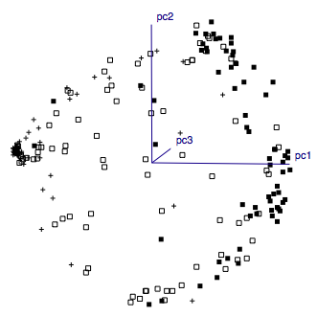 | 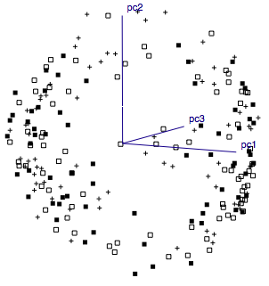 | 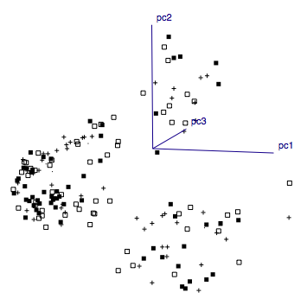 | 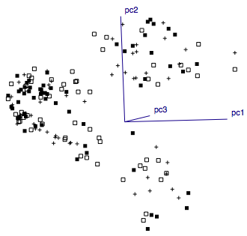
a. | b. | c. | d.
Fig. 3: Kernel-based clustering and visualisation in 3 dimensions of (a) illness dataset, (b) blood dataset, (c) gene expression dataset and (d) the integrated blood, illness and gene expression dataset. Legend: + = NF patient,  = ISF patient,  = CFS patient.

Fig. 4: Accuracy of ranked spots classifiers. Legend: × = “ARM Dens – Levels” and “SD – Levels”;  = “MAD – Levels” and “SD – Levels”.
Figure 4 shows the accuracy of SVM classification with different numbers of the top GFR ranked spots. The first points on the graph use the 500 lowest ranked spots for classification to illustrate the magnitude of the difference between classification accuracy at both ends of the ranking scale. The graph shows that many spots are required to reach an acceptable classification accuracy. Reductionist approaches assume that factors that affect the outcome of the classification act independently. If there is an attribute that is strongly correlated with another attribute, the advice (Occam’s razor) is to remove it. Hence, the fewer attributes - the better. However, genes may not necessarily fit well in this modeling paradigm, due to many possible interactions hence they are not independent. The large number of genes required to achieve reasonable classification accuracy in Fig. 4 suggest to us that there is not a clear biological marker consisting of a small number of genes to discriminate between fatigued and non-fatigued patients.

Interrogation of the Full Blood Count data with decision tree and association analysis indicated few stark differences at the cellular level between peripheral blood samples obtained from CFS vs ISF vs NF patients. Slight imbalances in a range of attributes associated with red blood cells (RBC) were detected which may be characteristic of a fatigue phenotype. These ‘imbalances’ however, were mostly in the normal range for these attributes within the general population and could not independently be used to diagnose a fatigue syndrome. For example, the decision tree identified that all CSF patients had a Mean Corpuscle Volume (MCV) ≥ 81.15 fl (normal range 86±10fl). Similarly, ISF patients were found to have a Mean Corpuscle Haemaglobin (MCH) ≥ 26.45pg, however, the normal range is 29.5±2.5pg. So whilst the RBC attributes are not sufficient to characterise a ‘fatigued’ patient as having a form of anaemia, these imbalances may point to slight inefficiencies in O₂ distribution of CFS and ISF patients. These attributes, however, are not sufficient of themselves to be used as a diagnostic marker for a fatigue syndrome nor may they reflect the underlying biological basis for the syndrome. That said, decision tree analysis identified that the non-fatigued samples were identified by CO₂ ≥ 21.4 units (58 of the 63 patients matching also MCH > 33.45 and anion gap ≥ 21.4). However, the CFS patients were identified by CO₂ ≤ 28.9 units. Given that the normal ‘non alerted’ range is between 20-30 units it appears that, for this attribute at least, the difference seen with the decision tree analysis may represent different distributions between the test and control patient cohorts, with both cohorts having values within a range found to be normal within the wider general population. Clearly however, the biological differences between the blood count and chemistry of the fatigued and NF patients is minimal to non-existent and not useful as an independent classifier of CFS. The imbalances detected may however, in combination with the other data available may allow the construction of a multifactorial/multigenic classifier for fatigue syndromes. Indeed, F Test analysis for the MCV and MCH variables indicate that the sample variances between the CSF and NF populations (non-MDDM identified samples, nor ISF samples) were significantly different (p<0.05 or 0.028 and 0.048 respectively).
Decision tree and association analysis of the “Illness Classification SF36 MFI and Symptoms” dataset identified rules that agreed with those used to empirically classify patients [6]. For example, NF patients were characterised with General Fatigue < 12.5, Reduced Activity < 9.5, no exclusion and no current MDDM. Similar rules used by [6] were identified for the CFS and ISF patients.

Discussion of the merits, assumptions, and limitations of your approach
The merits of our approach have been discussed earlier. The constructionist approach in this study applied linear kernels, which can model only linear relationships in the dataset. Like other reductionist approaches, the GFR technique assumes that the genes associated with the spot labels are independent. This methodological assumption is made for efficiency considerations. Reported analysis does not include SNP and proteomics. Our approach accommodates these additional datasets seamlessly. The efficient approach for calculating the kernel matrix for the gene expression data only works for linear kernels.

Conclusions
The objective of this study is to investigate whether there is a biological basis to CFS or whether it has a purely psychosocial aetiology. The high dimensionality of the integrated datasets and the predicted ‘multifactorial’ nature of the aetiology of CFS lead us to take a combined constructionist and reductionist approach to the data analysis. Reductionist approaches which search for local patterns, usually genes, as ‘biomarkers’ are complemented with constructionist approaches that identify global patterns in the integrated clinical and gene expression datasets. A kernel-based clustering and visualisation technique reveals clear (global) structure discriminating patient classes in the “Illness Classification SF36 MFI and Symptoms” dataset. However, structure corresponding to the different patient classes is less evident in the other datasets with this method. A Gene Feature Ranking technique identifies local patterns in the gene expression dataset. However, many genes are required to achieve patient class discrimination. Decision tree and association analysis explores patterns in the clinical datasets and likely indicators from the Full Blood Count data show a weak discrimination between patient classes. Attributes in the “Illness Classification SF36 MFI and Symptoms” dataset best distinguish between patient classes. These results suggest that there are not clear biological markers in the form of a few genes or attributes of the Complete Blood Evaluation to discriminate between fatigued and non-fatigued individuals. This suggests to us that any biological basis found for CFS will be subtle.
A combined constructionist and reductionist approach to exploring the biological basis for CFS is likely to be able to uncover these subtle patterns at least as well as a strictly reductionist approach. The study is an ongoing project. An additional investigation of the likely interdependencies of genes is currently being conducted with NetMap Analytics technology. We are further scrutinising clusters of the GFR ranked spots. Additionally, we are filtering the integrated datasets according to the clusters identified with the kernel clustering and visualisation method for decision tree and association analysis.

References
1. Hastie, T., Tibshirani, R. and Friedman, J., (2001) The Elements of Statistical Learning, Springer-Verlag.
2. Keerthi, S.S., Shevade, S.K., Bhattacharyya, C., Murthy, K.R.K. (2001), Improvements to Platt's SMO algorithm for SVM classifier design, Neural Computation, 13 (3), 637-649.
3. National Center for Infectious Diseases, (2005) Proposal: clinical assessment of subjects with Chronic Fatigue Syndrome and other fatiguing illnesses in Wichita, Available at: ftp://ftp.camda.duke.edu/CAMDA06_DATASETS/wichita_clinical_irb_protocol.doc.
4. Nicholson, AC., Unger, ER., Mangalathu, R., Ojaniemi, H. and Vernon, SD., (2004), Exploration of neuroendocrine and immune gene expression in peripheral blood mononuclear cells, Mol. Br. Res, 129 (2004) 193-197.
5. Platt, J., (1998). Fast training of support vector machines using sequential minimal optimization, In B. Schoelkopf, C. Burges, and A. Smola, (eds) Advances in Kernel Methods - Support Vector Learning, MIT Press.
6. Reeves, WC., Wagner, D., Nisenbaum, R., Jones, JF., Gurbaxani, B., Solomon, L., Papanicolaou, DA., Unger, ER., Vernon, SD. and Heim, C. (2005), Chronic Fatigue Syndrome – a clinically empirical approach to its definition and study, BMC Medicine, 3:19.
7. Shawe-Taylor, J. and Cristianini, N., (2004) Kernel Methods for Pattern Analysis, Cambridge University Press, pp 282-285.

* Corresponding author e-mail address: paulk@it.uts.edu.au

